Dear Colleague,

We wish you a warm welcome to joining and working in NHS Lothian. We would like to introduce ourselves and give you a little information about who we are and what we do.

The Lothian Local Dental Committee and GDP Sub-committee is responsible for representing the voices of GDPs across Lothian. There are 11 different Local Dental and GDP Sub committees across Scotland representing a number of different regions.

We discuss varying issues such as; delivery of dental care in the region, patient referrals, practice inspections and OOH emergency services, to name a few. The committee consists of 14 elected members and we hold meetings 5 times per year. Anyone is welcome to come along to these meetings and observe. A summary of our activities is circulated to every Lothian practitioner in our annual report in March of each year.

The work of the committee members is entirely funded by voluntary mandates from GDPs in the Lothian area. Currently this levy is £15 per month and is deducted from your monthly schedule.

What do you get for this £15 per month?

Most importantly, a voice and representation in the Lothian area (sometimes nationally depending on the topic). We are a central contact that can take matters further and to the relevant people. The committee members take time out of their practices to help represent all practitioners (NHS, mixed and private). As this can sometimes involve substantial time away from practice, a small proportion of the Levy is used to reimburse the committee members for their lost surgery time.

We also hold a number of CPD events throughout the year. These events are free to levy payers and you receive verifiable CPD hours for this. Topics in the past have included; oral surgery, dentures, radiology and digital dentistry. These events are also a great way to catch up and socialise with colleagues outside of the busy and stressful surgery environment.

We have a compressor and an autoclave available for any levy payer’s practice to borrow in the event of theirs breaking down.

I hope that after hearing about what we do and the potential benefits, you will consider subscribing to the levy. We are all busy practitioners and we all need to be represented and supported at some point during our professional career. Dentistry is going through a very big change at the moment and we need all the support we can get to maintain our representation, especially at this present time. If you would like to join, it is easy. Simply return the enclosed levy mandate to the email address below and the form will be processed for you. Alternatively, you can fill in the mandate form on our website. You will see the deduction on your schedule on Line 28.

More information about the committee can be found on our website. www.lothian-ldc.org

Yours,

STUART BANKS
Treasurer

How Representation is delivered through the LDC and GDP Sub committee

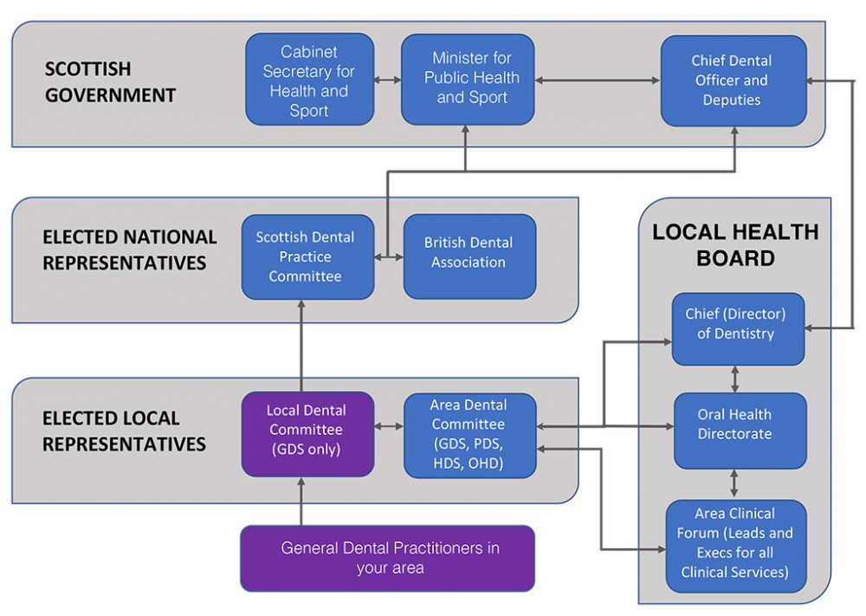

THE VOLUNTARY LEVY

AUTHORITY TO DEDUCT CONTRIBUTIONS BY MANDATE

To: NHS Board

I ...............................................................................(name in block capitals)

Of (GDC Registered ADDRESS)

-----------------------------------------------------------------

-----------------------------------------------------------------

-----------------------------------------------------------------

---------------------------(Post Code)

___________________(List No.)

Authorise the deduction from my monthly schedule of remuneration the sum of £15.00 (or such other sum as may be determined from time to time), to be paid to the General Dental Practitioners Sub-Committee (LDC). This supersedes any existing mandate, which may be in operation.

Signature.........................................................

Date....................................................................

