

Bonnyrigg Dental Centre

35-37 High street

Bonnyrigg

EH19 2DA

0131 536 8941

0131 537 8959 (Pathway Office, DSDC)

Dear Colleagues (please share with practice)

**PDS Paediatric Dental Referrals - unable to accept referral on paper**

Due to Covid 19 and redeployed staff we are now **unable to accept** any PDS Paediatric Paper referrals (which would normally be sent in via Bonnyrigg Dental clinic/Howden Dental Clinic.)

**All referrals to OHS should now be via SCI Gateway.**

Please submit your referral via SCI gateway, and note that any sent on paper will not be accepted and will be returned, resulting in delay for your patient.

From the menu in SCI gateway select **Oral Health Service**, and then **PDS Paediatric referrals**. These referrals will then be triaged/processed as before albeit remotely.

I am sorry that this is more onerous for you to complete. However SCI does have the advantage of being more secure and should remove the risk of referrals being lost.

Your help with this is very much appreciated in these uncertain times!

Yours faithfully,

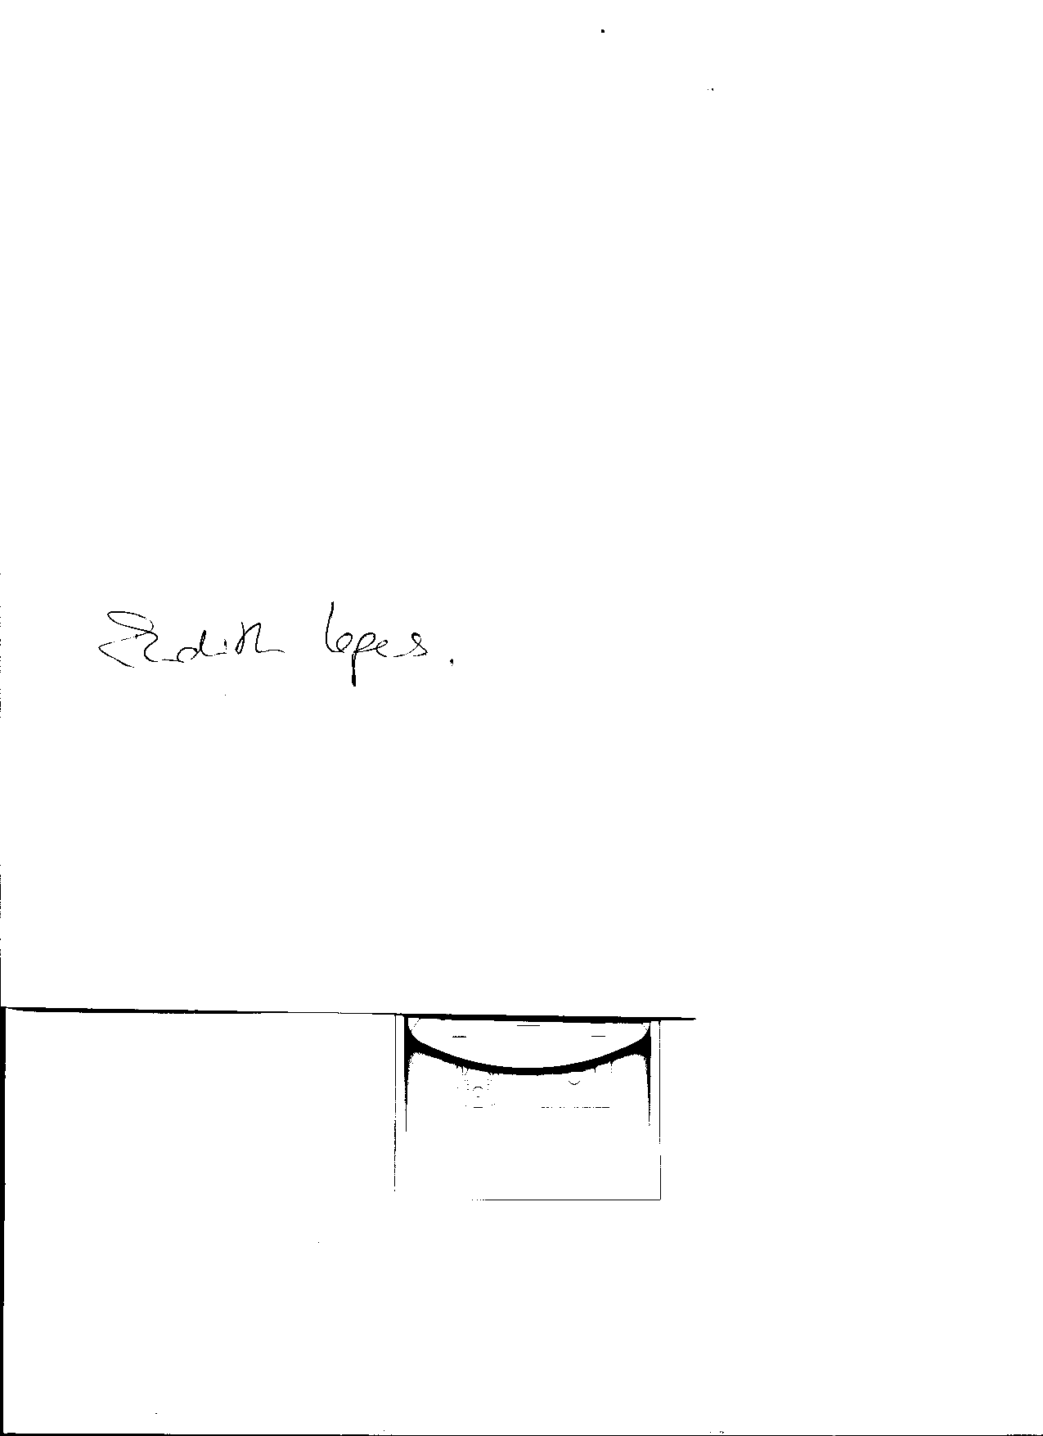

Judith Lopes

Assistant clinical Director

PDS Paediatric Team

NHS Lothian Oral Health Service