29th June 2020
Angus Walls, Director

Edinburgh Dental Institute
4th Floor Lauriston Building
Lauriston Place
Edinburgh EH3 9HA

+44 (0)131 536 4975
angus.walls@nhslothian.scot.nhs.uk
COVID-19 Update No 13
Content of this update
- Phase 3 and returning dentists

Dear Colleagues,

Phase 3 recovery

We have now been told that Phase 3 of the NHS recovery plan will commence around the 15th July. At that stage you will be expected to deliver non-AGPs for all patients and routine recalls for those patients.

In order to enable NSS to plan for the additional PPE that will be required for this activity they need to know how many dentists (in terms of whole-time equivalents) you would plan to bring back to in to work for this purpose. This will be affected by a mixture of your ability to accommodate social distancing both for patients and for staff within practices, all dentists tend to do a mix of NHS and private activity and of course there are a number of dentist who do not work part-time now and will they be returning to work?

Could you let us have an estimate of how many dentists in terms of whole-time equivalents you would anticipate working to do Phase 3 activity in the NHS in your practice? I appreciate that this may be a “best guess” at this stage but if we don’t have that NSS are shooting at a completely empty goal.

We need this return by the end of business on Thursday (2nd July). I appreciate that this is very short notice but would greatly appreciate your support. A simple email to PCCO with the information would be appreciated (dental.contract@nhslothian.scot.nhs.uk).

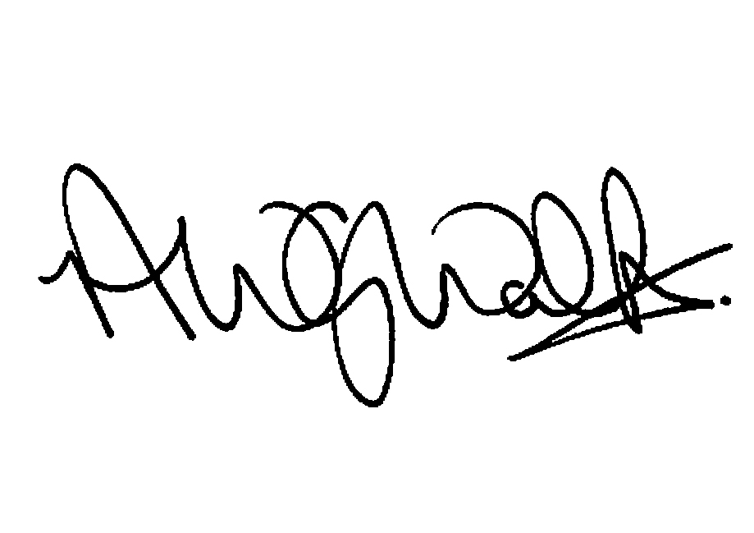
With all my best

Angus Walls

