9th April 2020
Angus Walls, Director

Edinburgh Dental Institute
4th Floor Lauriston Building
Lauriston Place
Edinburgh EH3 9HA

+44 (0)131 536 4975
angus.walls@nhslothian.scot.nhs.uk

COVID-19 Update No 6

Content of this update
- Redeployment

Dear Colleagues,

As you will be aware the current coronavirus epidemic is subjecting the NHS medical services to increasing pressure, pressure that is likely to escalate in the the coming days and weeks.
The Lothian Oral Health Service has received requests for manpower assistance in emergency departments in Lothian, Fife and Borders. NHS Lothian are asking for volunteers from the GDS to come forward to work in hospitals, primary care assessment centres and testing hubs. We are also interested to know of any practitioners who have transferrable or enhanced skills that could compliment or assist existing medical personnel, for example, practitioners who have experience of working in A&E and OMFS departments and/or experience in venupuncture and sedation​.

At this stage we are asking people to volunteer for redeployment however all listed Lothian practitioners should be aware that PCA (2020)(6) item 6, does identify that a condition for entitlement to the NHS financial support package is conditional on the willingness to 'assist the wider NHS, including the PDS, when asked by the NHS Board'.

Initially we would ask all Lothian based practitioners and DCPs to fill in the attached questionnaire.​​ The completed questionnaire should be returned to dental.contract@nhslothian.scot.nhs.uk DCPs who have been furloughed can still volunteer as they will not be working in the same capacity as they were, prior to being furloughed.​

Thank you all once again for your support and with all my best
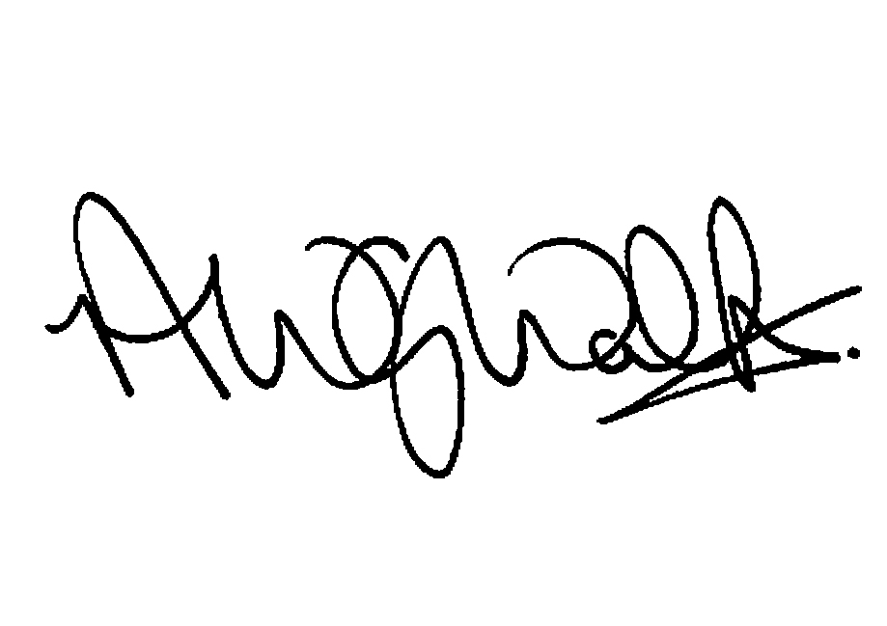
Angus

